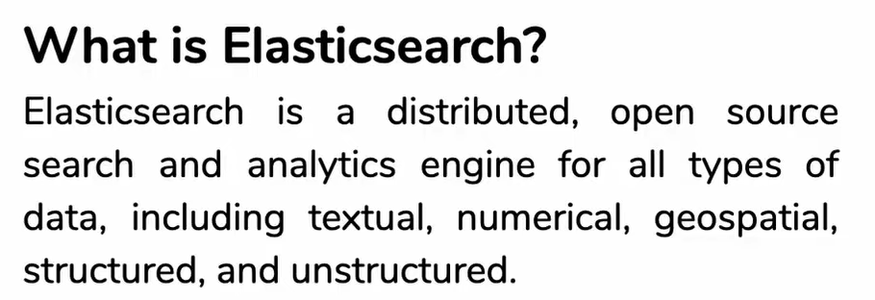

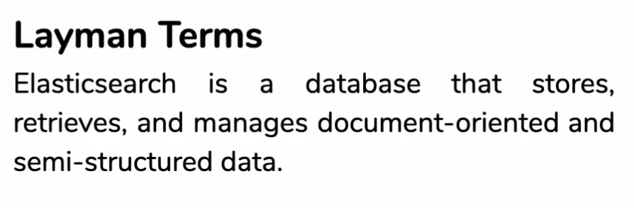

It stores data in the format of Json when we Quary then the data is retrieved from database.

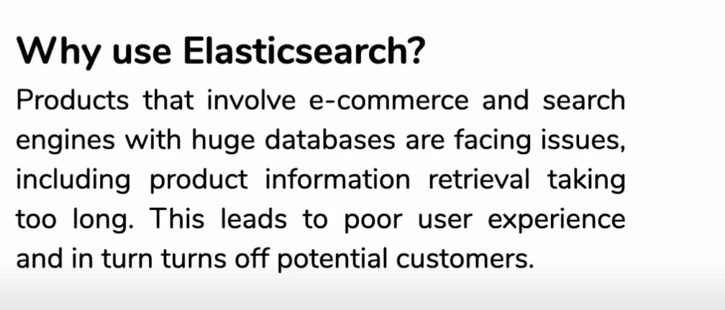

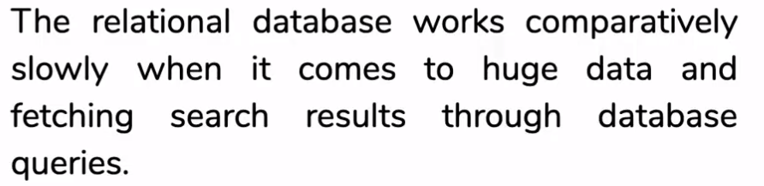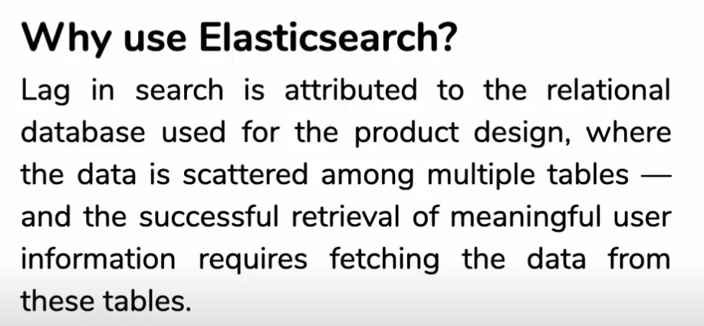

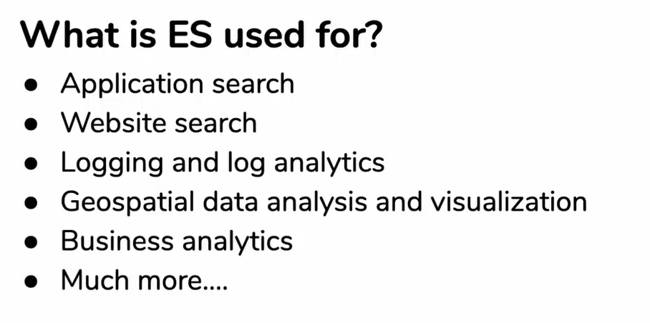

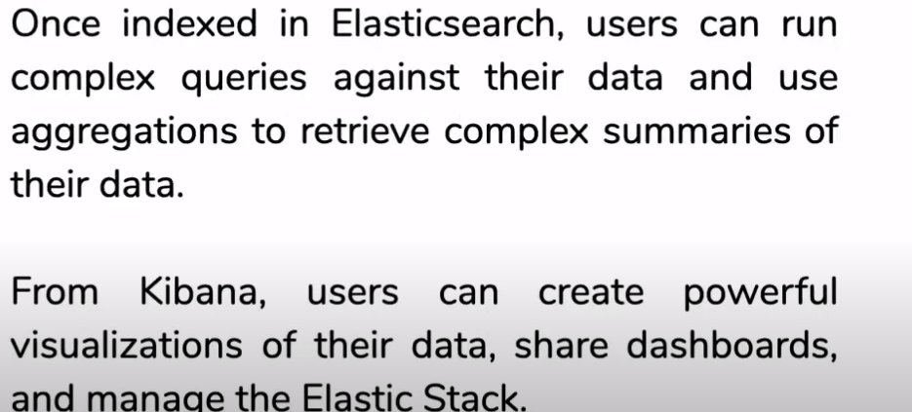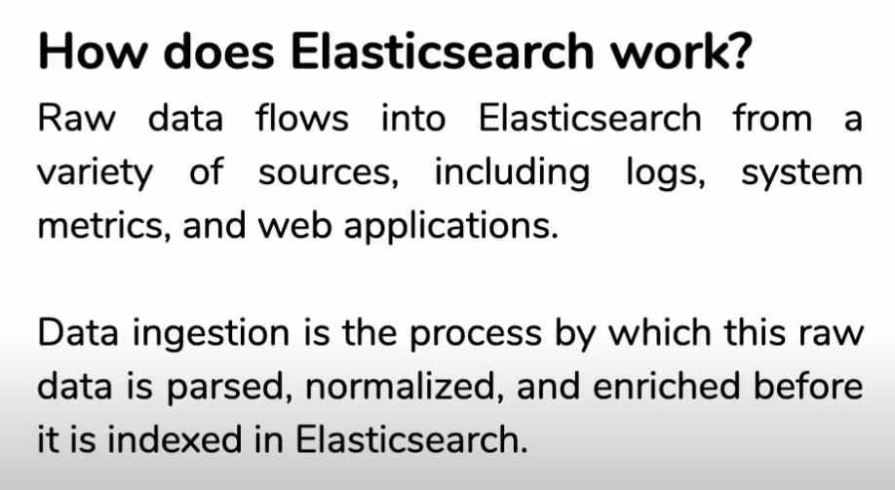

Imagine you have a toy store, and you want to keep track of all the toys, their details, and what customers think about them. The Elastic Stack is like a set of special tools to help you do that.

1. **Elasticsearch:** Think of this as your magical toy catalog. It's like a super smart book that lists every toy in your store and where to find them. If someone asks for a red ball, Elasticsearch helps you quickly find where all the red balls are.
2. **Logstash:** Now, let's say customers write reviews about toys on little pieces of paper. Logstash is like your helper who takes these papers, reads them, and organizes the information. It makes sure that everything about the toys is in the right order.
3. **Kibana:** Kibana is like a special pair of glasses that helps you see all the information in a super cool way. You can make graphs, charts, and maps to understand which toys are the most popular or where they are located in your store.
4. **Beats:** Imagine little messenger toys that go around the store and bring you updates. Beats are like these messengers, keeping an eye on what's happening with the toys and reporting back to Logstash and Elasticsearch.

So, the Elastic Stack is like a team of toys working together. Elasticsearch is the brainy catalog, Logstash is the organizer, Kibana is the glasses for seeing things clearly, and Beats are the messengers keeping everything up to date. Together, they help you manage, organize, and understand all the information about your toys (or data) in the store.

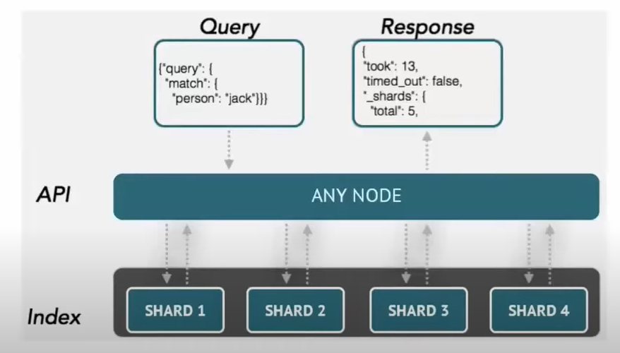

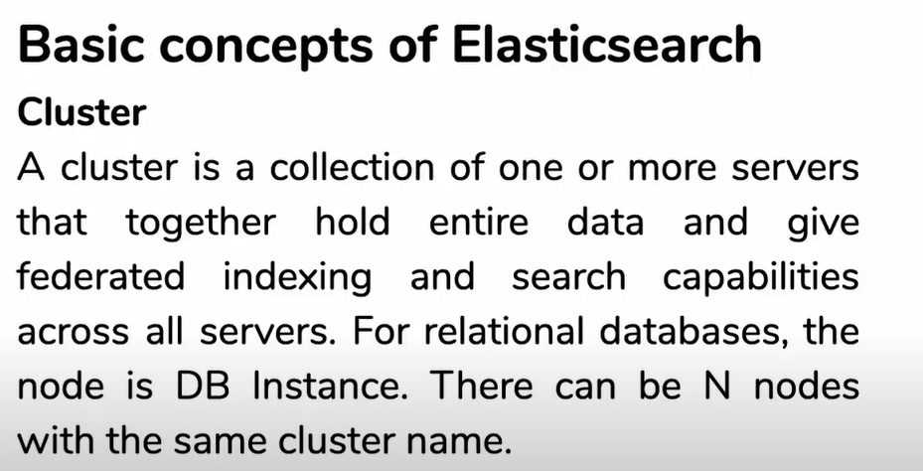

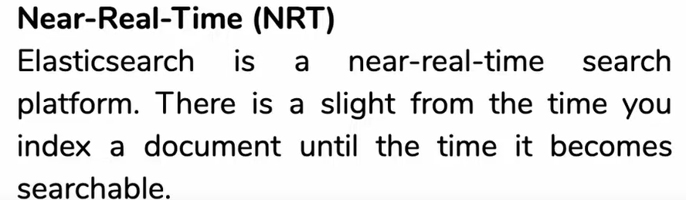

1. **Index:**
   * In our toy store, think of an index as a specific section of your catalog. For example, you might have an index for cars, another for teddy bears, and so on. Each index holds specific types of toys.
2. **Document:**
   * A document is like an individual toy entry in your catalog. If you have an index for cars, each document represents a specific car and contains information about that car—color, model, etc.
3. **Type (deprecated in newer versions):**
   * Previously, types were used to further categorize documents within an index. Continuing with our analogy, within the "cars" index, you might have types like "sports cars" and "sedans." However, in newer versions of Elasticsearch, types are being phased out.
4. **Node:**
   * Nodes are like different branches of your toy store. Each node is a part of the overall Elasticsearch system and contains a subset of your data. Just as different branches store different types of toys, nodes store different parts of your data.
5. **Cluster:**
   * Now, imagine your entire toy store, including all its branches, as a cluster. A cluster in Elasticsearch is a collection of nodes working together to manage your entire catalog efficiently.
6. **Shard:**
   * If you have too many toys to fit in one branch, you might divide them into smaller groups and spread them across multiple branches. In Elasticsearch, a shard is like one of these smaller groups of data. Each shard is stored on a different node.
7. **Replica:**
   * Replicas are like backup copies of your catalog in case something happens to one of the branches. In Elasticsearch, replicas are additional copies of your data stored on different nodes for fault tolerance.

Top of Form

